EGL Walkthrough
Last updated October 1, 2009

EGL Walkthrough 1
Getting EGL CE 1
Set up the Project (One time per LM server) 1
Create the Project in your Workspace (one time per developer) 3
Description of EGL “Deployments” 4
Set up EGL Deploy Web Project 5
Walkthrough: Preliminary Steps 11
Walkthrough: EGL Developer 11
Walkthrough: IBM i Developer (Optional) 12
Walkthrough: Check-in Developed Source Code 12
Walkthrough: Generate and Deploy the AldonEGLDeploy Web Application 12

Getting EGL CE
- If you don’t want to download EGL CE onto your laptop, or do the set up, you can sign in to PSG-TS as user DONC (ask Joe, Modi or Anita for the password). It is all set up and configured there for us all to share.
- To download or post questions to the forum, you must register on the EGL Cafe.
- Visit the new EGL Community Edition hub on the EGL Cafe for general information, system requirements, FAQs, and to read and post questions - http://www.ibm.com/software/rational/cafe/community/egl/ce
- You have two choices for a download
  - You can download a stand alone EGL CE IDE
  - You can download EGL CE as a plug in.
    - The plug in requires eclipse 3.4 so make sure you’re IDE is running on that level.
    - Note here: so far, I have only been able to install this plug in into the Eclipse 3.4 IDE.
- To download - http://www.ibm.com/software/rational/cafe/docs/DOC-3216
- Installing as a plug-in to RDi 7.5
  - You will get to a point in the instructions where you come to this screen 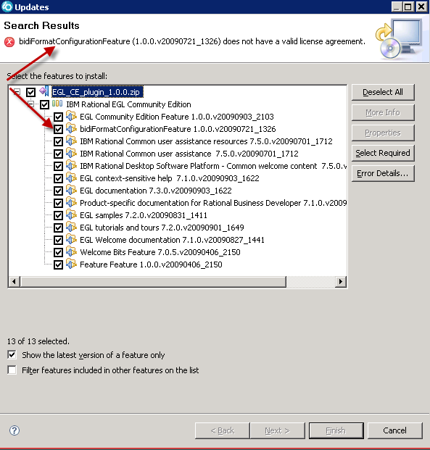
  - According to EGL experts in the EGL Café, the bidi function is optional, so deselect it and then press Finish.

Set up the Project (One time per LM server)
- NOTE: This step has already been done on our psg-lmx local server. You just need to pull in the application from LMe via the next section: “Create the Project in your Workspace”.
- The application is called “AldonEGLData”. You do NOT need to install the AldonEGLWar project.
- It is copied from the samples project that was loaded when you installed EGL CE: /com.ibm.egl.rui.samples.ce/EGLSource/gallery/datadisplay 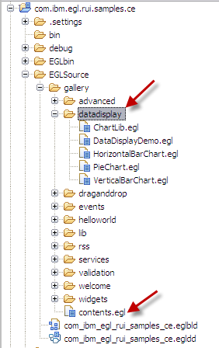
- These projects contain the widgets for EGL Rich UI and Dojo, as well as samples of how to use the widgets. Explore the com.ibm.egl.rui.samples.ce project, by opening the contents.egl file under EGLSource>gallery and clicking on the Preview tab.
- Create the Group/Application/Release and environments in LMe. For example, ours on psg-lmx is called Web/EGL/AldonEGLData(1.0)
- RC on the project and share it with LMe
- Open up the project in the Navigator view (the Project Explorer view does not show all the structure).
- Only certain structures in the workspace project need to be managed by LMe. If you manage the entire project structure, you will have problems later when EGL generates artifacts into these structures but fails because they are marked as “read only” because you didn’t check them out. For some reason, LMe does not prompt you to check out these changing items. They are typically nothing you need to version control anyway!
- RC on the following highlighted structures and add them to LMe’s control. 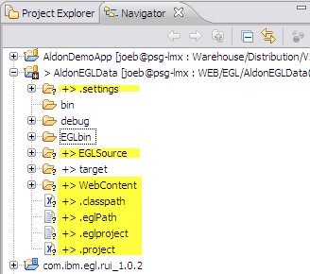
- RC on the project (AldonEGLData in my example) and select Team, Check in.
- You will see the following prompt to ask you if you want to add the items that we did not initially put under Aldon’s version control above. Select NO! 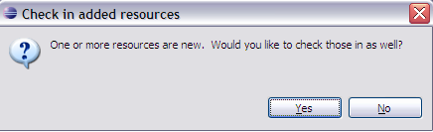
- Promote your items all the way to production.

Create the Project in your Workspace (one time per developer)
- Open up your IDE.
- Open the Aldon LM Repositories view
- Expand the connection
- Find the AldonEGLData project and the release, RC and add to workspace
- Open up LMe
- Add a development environment to your developer that maps to the AldonEGLWar project. I placed mine in c:/EGL_Build_Scripts 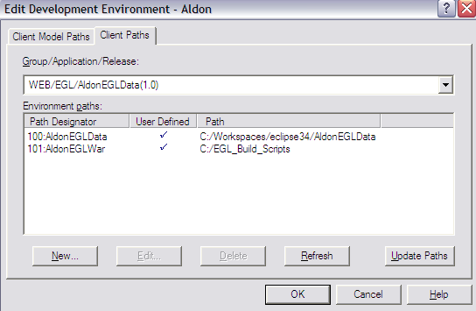
- Return to EGL CE
- Follow the steps in “Set up EGL Deploy Web Project”

Description of EGL “Deployments”
In order to create the actual working web application, EGL must “deploy” the source. This is not a deployment in the Aldon sense of the word, so be careful not to get too confused. This act of deploying does NOT send the application to another server. It is more like a “compile” process.
An EGL project typically corresponds to an application. You develop an EGL application in an EGL project, and then deploy the EGL project to a dynamic Web project. Although the deployment project is in the workbench, you configure the project to match the characteristics of the environment where you plan to deploy your application. If you need to run the application in different environments, you can deploy a single EGL project to multiple dynamic Web projects. For example, you might create an application to run on two local area networks, each of which uses a different version of Apache Tomcat. You can create a dynamic Web project for each network and deploy your application to both projects.
During the development process, EGL automatically generates code (JavaScript™ from Rich UI programs, and Java™ from services) each time you save a source file. When you deploy that code, EGL completes the following additional actions:
- Packages the JavaScript (.js) files into HTML files
- Adds server-specific code to the project files

For deployment, RUI code is compiled into HTML and JavaScript, services are compiled into Java as SOAP or REST Web services. Code is then deployed as a JEE application into a Web application server.

After you deploy your files to a dynamic Web project, take the following actions to export to your application server:
- For a partially JEE-compliant application server such as Apache Tomcat, right click the Web project, then click Export > Web > War file.
- For a fully JEE-compliant application server such as WAS: ensure that the application.xml file includes your database-access information, then right click right click the Web project, then click Export > Java EE > EAR file.

For more information, in the Eclipse 3.4 IDE, click Help, Help Contents, Deployment.

Set up EGL Deploy Web Project
- Find the EGL Deployment Descriptor (.egldd) under the EGLSource tree. 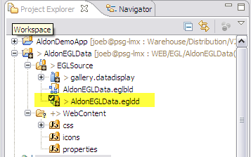
- Check it out.
- DC on it to work on its properties.
- Specify a new Web Project (NOTE: Steps 3 - 5 only needs to be done one time per developer). 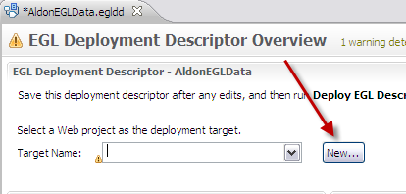
- Enter in the Web Deployment project’s name of AdonEGLDataDeploy
- In the Target Runtime, click New and fill out as shown here 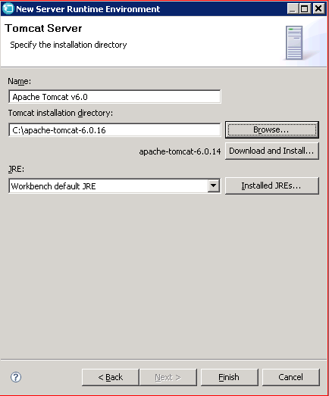
- Accept the remaining defaults and click finish. 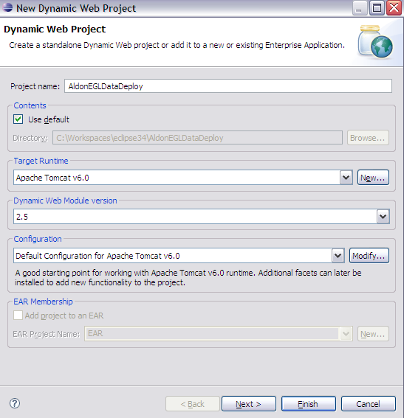
- You now return to the Deployment Descriptor editor. Save your work so far via CTRL-S.
- In the upper right hand corner of the window, you’ll see an icon that when you hover over it says “Deploy this EGL Description” . Click that button.
- You will now have a Web Application Project in your workspace that looks something like this: 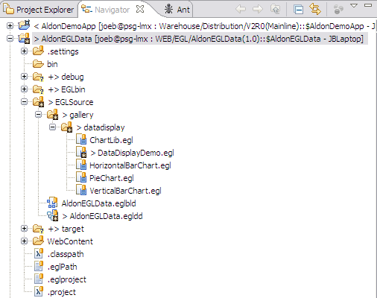
- Now RC on the EGL source project and select Deploy EGL Project 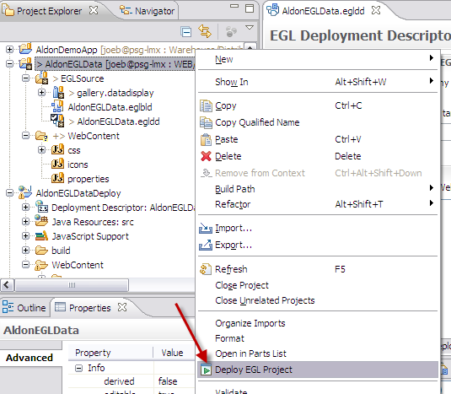
- You will now have a Web Application project that looks something like this. NOTE: This project does NOT need be maintained by Aldon. 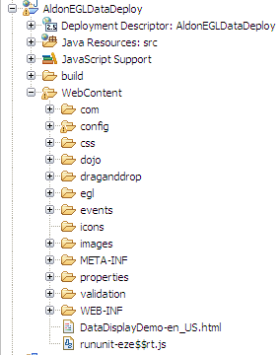
- Just under the WEB-INF folder you will see an html file. This html was generated by the EGL build and deploy process. RC on it and select Run on Server 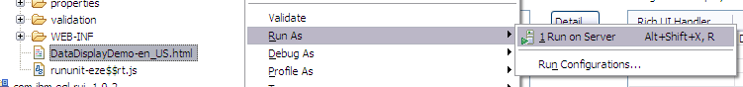
- Select the Tomcat server on your local workspace and then Finish. 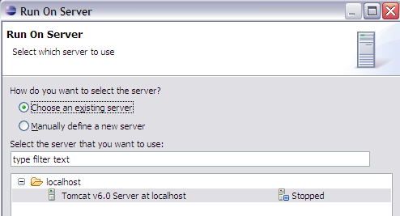
- You should now see the web application fire up in the editor’s built in browser window. Note the address. You can also open this up from an external browser like Firefox or IE. 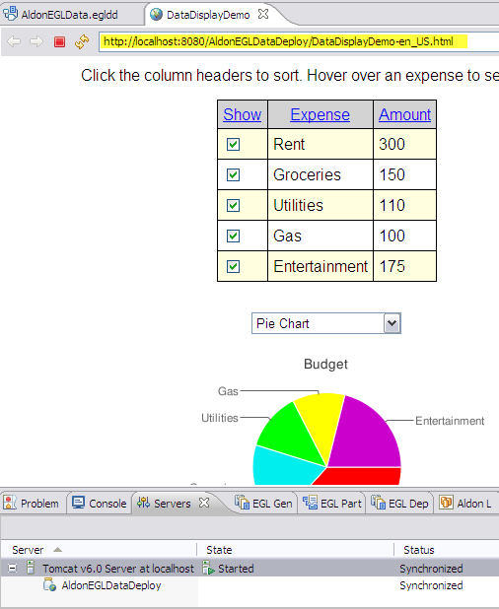

Walkthrough: Preliminary Steps
- Open Eclipse 3.4 on your pc
- Open LMe on your pc
- Create the task in both LMe and LMi
- Open up a browser to show the live app: http://psg-ts:8080/AldonEGLDataDeploy/DataDisplayDemo-en_US.html
- Show current application
  - Open AldonEGLDeploy project, WebContent, DataDisplayDemo-en_US.html
  - RC, Run As, Run on Server
  - Select Apache Tomcat 6.0 at localhost
  - Finish
  - OR http://localhost:8080/AldonEGLDeploy/DataDisplayDemo-en_US.html

Walkthrough: EGL Developer
- In Eclipse 3.4 IDE, navigate to the EGL perspective
- Show how Aldon is managing the repository, show the Aldon views, etc.
- RENT IS GOING UP!
- Open up the AldonEGLData project (managed by Web/EGL/AldonEGLData 1.0)
- Expand EGLSource, gallery.datadisplay
- Open up DataDisplayDemo.egl
- RC Team Checkout
- Move to the Source view tab
- Page down until you find “Rent” and change the amount.
- Switch to Preview tab and confirm.
- Save and exit the source.
- RC on the AldonEGLData project, Deploy EGL Project
- The view switches to the EGL Deploy Results and you should see the message: Info: Rich UI Handler gallery.datadisplay.DataDisplayDemo was successfully deployed to: /AldonEGLDeploy/WebContent/DataDisplayDemo-en_US.html
- This deploys the AldonEGLData project to a web application project called AldonEGLDeploy via instructions captured in the project’s egl deployment descriptor file AldonEGLData.egldd
- Show changed application
  - Open AldonEGLDeploy project, WebContent, DataDisplayDemo-en_US.html
  - RC, Run As, Run on Server
  - Select Apache Tomcat 6.0 at localhost
  - Finish
  - OR browse to http://localhost:8080/AldonEGLDeploy/DataDisplayDemo-en_US.html if you’ve already started the local server before.
- NOTES:
  - Saving the source automatically triggers the EGL Build process. EGL build is the process of validating and compiling EGL source and then writing the compiled output to IR files.
  - The IR files are an input to EGL Generation, which is the following internal process:
    - Validation of your work for its conformance to a particular target runtime; for example, for use in a browser.
    - Generation of source code as JavaScript™, to use in a browser, or as Java™, to use as a Web service implementation. With the commercial EGL products, you can also create COBOL output
    - A build file (.eglbld), which includes details about what is being generated. The most important element in the build file is the EGL build descriptor.
    - An EGL deployment descriptor (file extension .egldd), which is used to control aspects of service access and service deployment.

Walkthrough: IBM i Developer (Optional)
- From LMe, navigate to the IBM i components of the application.
- Checkout an RPG program ARS0301 to the task being used

Walkthrough: Check-in Developed Source Code
- The development of the code has been unit tested and is ok to be checked in.
- Return to LMe and switch to the collection view.
- Check in all the EGL source and the IBM i object
- THE DEVELOPERS ARE NOW DONE!

Walkthrough: Generate and Deploy the AldonEGLDeploy Web Application
- We are now the company Build Manager. This is typically a separate person.
- Build could be done daily, weekly, whatever.
- Because we are not demonstrating BRM, we will manage the WAR file as an item and checkout, promote and deploy that item via LM.
- Open up LMe and navigate down to the AldonEGLWar project.
- Check out the WAR file to development for the task being using (NOTE: This step takes about 30-45 seconds on a remote PC because of the size of the WAR file and the slow connection. Doing it from PSG-TS as DonC is VERY fast).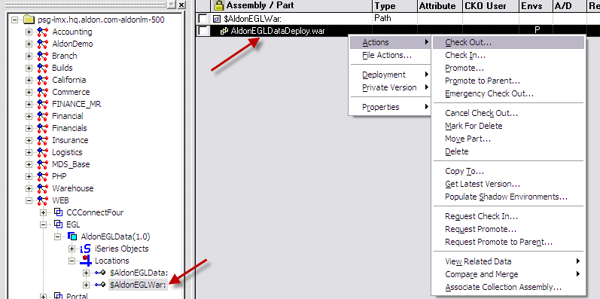
- Now the WAR file is in C:\EGL_Build_Scripts\AldonEGLDataDeploy.war
- The first thing this person wants to do is to update his copy of the source project.
- RC on AldonEGLData, Team, Force Get Latest
- RC on the web application project, AldonEGLDataDeploy
- Select Export, then select Web/WAR 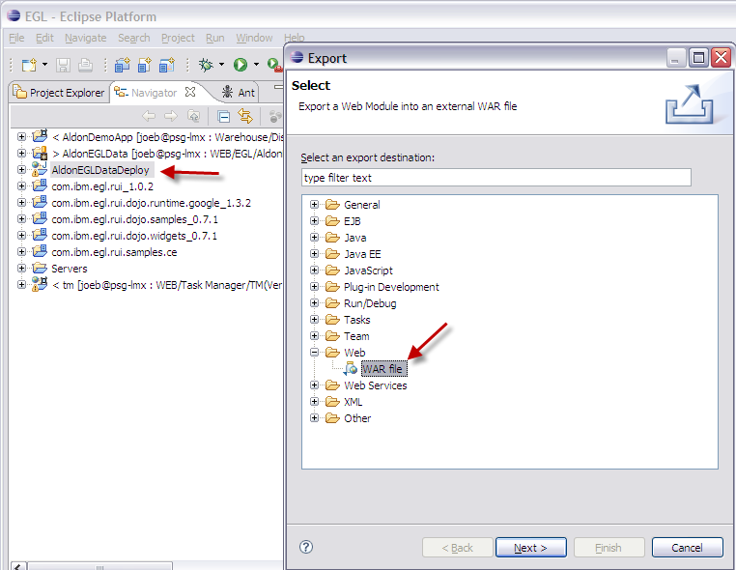
- Export the war file to overlay C:\EGL_Build_Scripts\AldonEGLDataDeploy.war 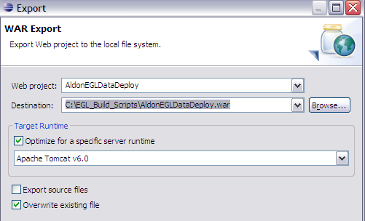
- Return to LMe
- Check the WAR file back in (NOTE: this is about 30-45 seconds for remote users due to the size of the file. VERY fast if DonC on PSG-TS)
- Show that all items for the task, both source, object and WAR, are now in Unit test.
- Select the entire task at this point and promote everything to QUA (there is no deployment currently configured here, but mention their could be).
- Select the entire task again and promote to PDN.
- Select the deployment profile of AldonEGL 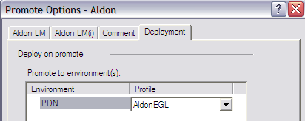
- This will send only the WAR file to psg-ts. The EGL source and deployment descriptors are filtered out.
- The WAR file is installed on PSG-TS in c:/apache-tomcat-6.0.16/webapps/
- Because the web application is running, Apache updates it instantly, no refresh or exit commands are necessary.
- Show the updated web site: http://psg-ts:8080/AldonEGLDataDeploy/DataDisplayDemo-en_US.html

